**Project report**

**on**

**ImVidhyarthi.com**

**PROJECT-BASED LEARNING (PBL-2) LAB (CSP398)**

**B. TECH. 3rd YEAR**

**SEMESTER: 5th**

**SESSION: 2022-2023**

**Submitted By:**

|  |  |  |
| --- | --- | --- |
| **Vishal Pandey**  **2020490363** | **B. Krishna Reddy**  **2020500084** | **Anjali Gupta**  **2020521668** |

**Submitted To: Dr. Rajendra Kumar**



**DEPARTMENT OF COMPUTER SCIENCE & ENGINEERING**

**SHARDA UNIVERSITY, GREATER NOIDA**

**Declaration**

We Vishal Pandey, Krishna Reddy, Anjali Gupta students of B. Tech. 5th Sem. have completed project ImVidhyarthi.com. We hereby declare that this is our original work and not submitted earlier in any institute/university for any purpose.

Vishal Pandey 2020490363

B. Krishna Reddy 2020500084

Anjali Gupta 2020521668

**Sharda university, Greater Noida**

**Sharda School of Engineering & Technology**

**Department of Computer Science & Engineering**

**Certificate**

This is to certify that Vishal Pandey, B. Krishna Reddy , Anjali Gupta have completed project ‘ImVidhhyarthi.com’ Under my supervision. This work is done by students and not submitted earlier in any university/Institute to the best of my knowledge. I wish them all the very best for their future.

Dr. Rajendra Kumar

Project Guide

**Table of Contents**

1. Project Title……………………………………………………………………………………………………………………………………….1
2. Team Details……………………………………………………………………………………………………………………………………..1
3. Technologies to be used……………………………………………………………………………………………………………………1
4. Problem Statement…………………………………………………………………………………………………………………………..1
5. Literature Survey………………………………………………………………………………………………………………………….…..1
6. Project Description………………………………………………………………...............................................................2
7. Project Design & Algorithms………………………………………………………………………………………………………….….2
8. Implementation methodology…………………………………………………………………………………………………….……4
9. Result & conclusion……………………………………………………………………………………………………………………….…5
10. Future Scope and Further enhancement of the project…………………………………………………………….……..6
11. Advantages of this Project…………………………………………………………………………………………………………….…6
12. Outcome………………………………………………………………………………………………………………………………………...7
13. References………………………………………………………………………………………………………………………………….….7

**ImVidhyarthi.com**

**Team / group details:**

|  |  |  |  |
| --- | --- | --- | --- |
| **1** | **Vishal Pandey** | **200101356** | **2020490363** |
| **2** | **A B. Krishna Reddy** | **200101092** | **2020500084** |
| **3** | **A Anjali Gupta** | **200101** | **2020521668** |

# **Technologies to be used:**

In this project , we will be using web technologies and the IDE we will use is VS Code.

**Languages and tools : HTML, CSS, JAVASCRIPT, PHP, MySQL, PHPMYADMIN, Bootstrap.**

# **Problem Statement**

“Time is Money”

~ Benjamin Franklin

As quoted by Benjamin Franklin “Time is Money”. In today’s time people lack time especially students which makes it hard for them to maintain their projects, assignment, attendance. Hence, we are developing a website called ImVidhyarthi.com which is basically LMS helps you to maintain your assignment, attendance, projects easily at one click and also secure.

Keywords: Security, Attendance, Assignment, Projects

# **Project Description**

ImVidhyarthi.com is a website/LMS which helps students to maintain and access their projects, assignments and attendance with ease and also your data here is very secured. This website is made using following web technologies:

* + - HTML for structuring the website
    - CSS for styling
    - Bootstrap for styling and structuring
    - JavaScript for providing some functionalities
    - PHP for Backend
    - MySQL and PhpmyAdmin for Database Management.

**Project Design & Algorithm**

**Home Page:**

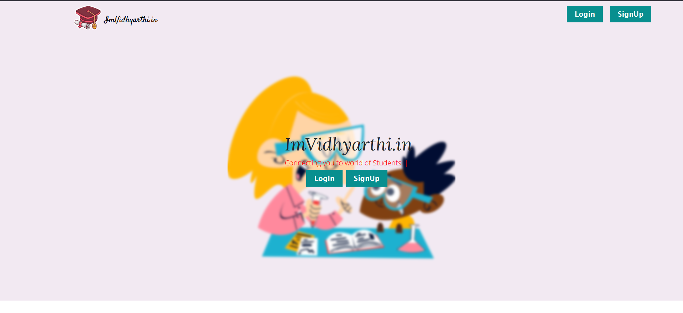

**Fig1: Home Page**

This is the first page you are directed to when you first visit our webpage. Form here you can registered to our app by singing up and also you can login by using your registered email and password.

**Registration System:**

Registration system is designed using CSS and PHP for backend queries. Our registration system is highly secured you password are hashed also 2 layer hashing is used.

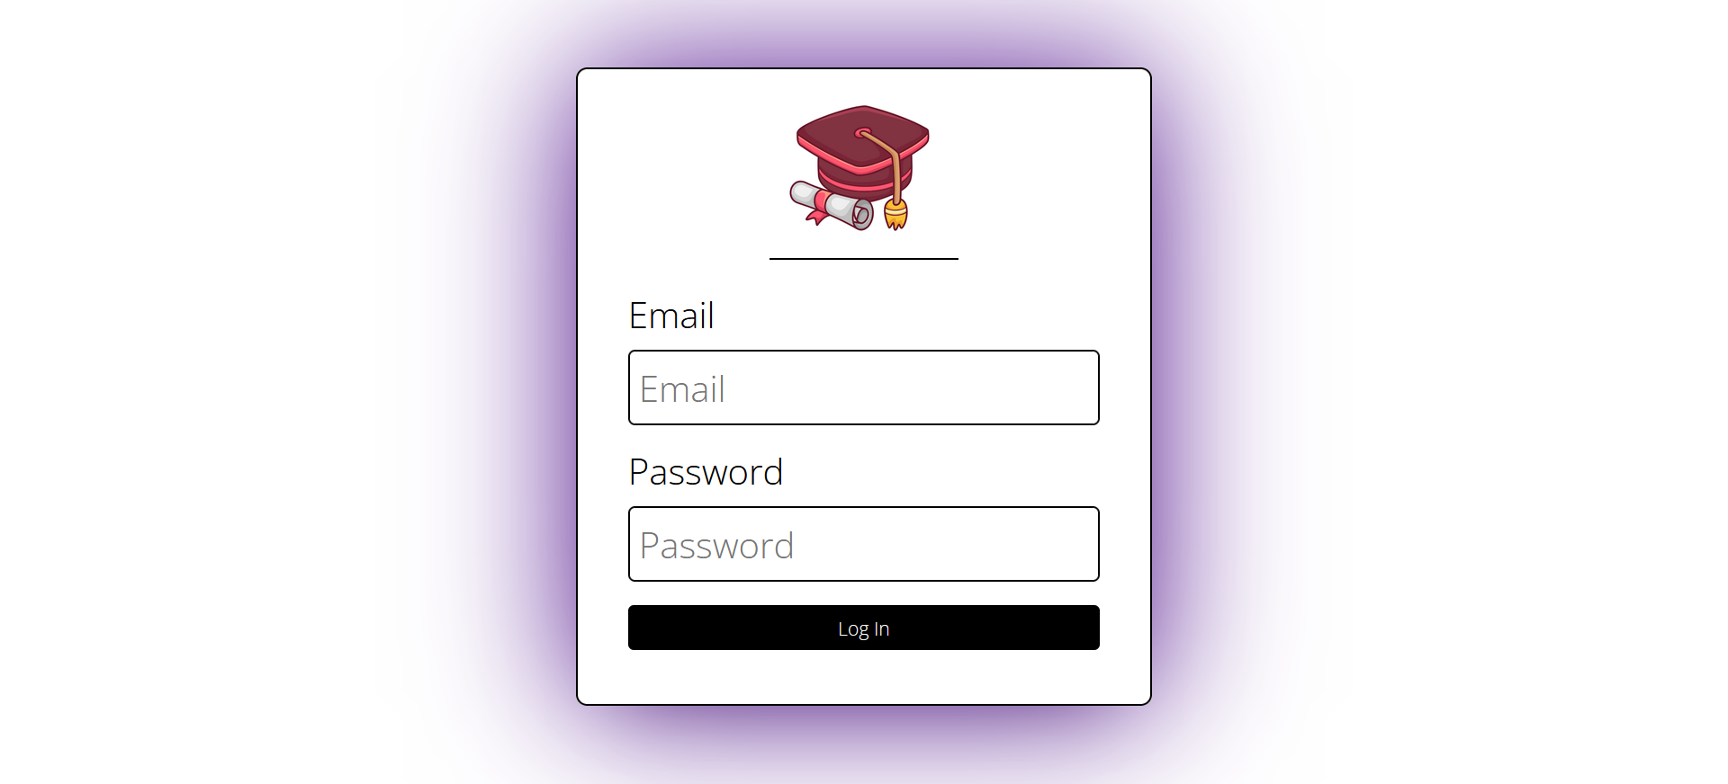

# 

# **Fig2. Registration System**

**Other Functionalities:**

Many other functionalities are provided by our site like one can check there attendance, profile, update there profile, upload and store projects and also maintain their assignment.

# **Implementation Methodology**

We have used Hyper Text Markup Language (HTML) for structing of the website, CSS and Bootstrap are used styling purposes and EJS is used to provide some functionalities and PHP language is used to connect to client-side server.

* **Wireframes and prototypes creation:**

A wireframe is a schema of a future web page. It includes all block that is to be placed on the page.

* **UI design:**

After wireframe design, we now move to design User Interface of the website. Use of different icons and colors are made to make the UI look good.

* **Front-end development:**

A front-end developer implements all the features and checks the responsiveness of the website, and also website is cross-browser compatible or not.

* UI designs are developed by myself and some references were taken from my previous websites.
* Design from GoDaddy ,etc.

Background Studies:

What is Web Development?

Web development simply means building, creating, and maintaining of websites. It includes web designing, web publishing, web programming, and database management. It is the creation of applications that works over the internet i.e., websites and web apps.

Some applications of Web Development:

* + Service Based Websites
  + Chat Apps
  + Search Engines
  + Organizations Websites

Types of Web Development:

Web Development

Back-end Development

Full-stack Development

Front-end Development

Web Development is primarily classified into three categories:

1. **Front-end Development:** Front-end Development basically deals with the UI of the Websites; it is responsible for the look and feel of websites which means it is responsible for how colors, icons, images, etc. will appear. It includes the use of languages like HTML, CSS, and JavaScript. Front-end developers keep up with cutting-edge trends in web design and development to make sure websites are optimized for users and search engines.
2. **Back-end Development:** Back-end Development basically deals with the databases and server managements. It is responsible for the data coming from the server to the websites and the security and accessibility of the data. It includes the use of languages PHP, MongoDB, SQL, etc.
3. **Full stack Development:** Full stack Development deals with both front-end and back- end and is responsible for both UI and Data from the server. Use of languages like HTML, PHP, JavaScript, CSS etc. is there.

Front-End Development

Front-end Development basically deals with the UI of the Websites; it is responsible for the look and feel of websites which means it is responsible for how colors, icons, images, etc. will appear. It includes the use of languages like HTML, CSS, and JavaScript. Front- end developers keep up with cutting-edge trends in web design and development to make sure websites are optimized for users and search engines.

Result

LINK FOR PROJECTS:

* www.ImVidhyarthi.com

## Conclusion

Different apps and frameworks and database queries were used to develop this product which helped us to gain more knowledge and learn about different web technologies.

Limitations of Web Development

1. Continue to Run in the Background
2. Anti-Virus Protection
3. A lot of advertisement
4. Security

Future Scope:

* + Much better UI/UX Designs
  + Better features like search, more about contact, etc.
  + More Functionalities
  + Registration System, etc.